Zazacron Fly and Cockroach killer wettable powder leaflet
Zazacron is a wettable powder against flies and cockroaches. It is a product registered to the National Environment Agency.
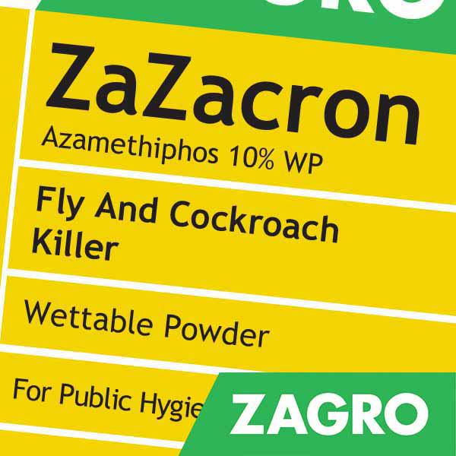
Spray:
200gm to 1.5lt for 40-meter square on the ground.
200gm to 1.5lt for 80-meter square on a wall.

Paint:
200gm to 200ml for 40-meter square on the ground.
200gm to 200ml for 80-meter square on a wall.

Scatter Bait method: Scatter Zazacron on surfaces where flies gather.
Station and tray method: Spread Zazacron on a tray evenly to avoid heaps.

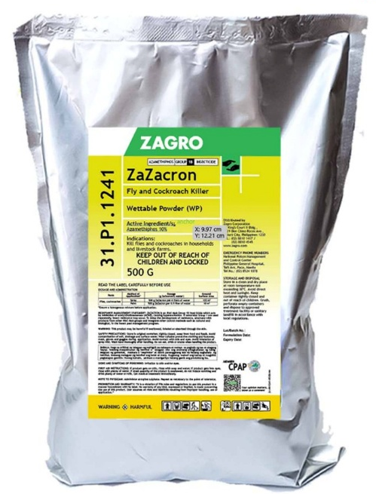
Hang board method: Lightly moisten one side of a board with beaten egg, beer, cola and sprinkle Zazacron on surface. When dry hang where flies gather.

Zazacron: Acts as an insecticide and an attractant to flies.
A new option in poultry for rotation with other insecticide.
Effective from 4 to 8 weeks with 6 weeks residual.
Reduces house fly population, effective even from 30 minutes.
Safe for farmers and livestock.

Zazacron: Is also recommended for use in homes, hotels, restaurants, and bars.

